**Mutational supply and epistasis determine the utility of traits by constraining adaptive paths**

**Background:** Biological characters can be lost over evolutionary time if they are unessential or disadvantageous (Porter and Crandall, 2003; Jeffery, 2005; Visser *et al.*, 2010; Fong *et al.*, 1995). In most cases, whether the character in question decays, gets maintained, or enhances during evolution is expected to be determined by the environment in which evolution takes place (Cooper, 2014). For example, extremely dark environments have been invoked to explain the loss of eyes in multiple systems (Jeffery, 2005; Protas *et al.*, 2011). Similarly, the metabolic erosion observed over >50,000 generations in the Lenski Long-Term Evolution Experiment (LTEE) has been linked to the presence of only one usable carbon source throughout evolution (Leiby and Marx, 2014). Thus, the utility of a biological character in its given environment is expected to determine its evolutionary fate. Furthermore, in a given environment, the character in question is expected to be either useful or unessential (but never both).

However, our recent experiments have revealed that adaptation to the *same* environment can result in the decay or enhancement of a character based on differences in population size. Specifically, while adapting to an environment with a cocktail of three antibiotics, small enhanced their ancestral efflux activity, but large populations lost it.

Using a toolkit of basic evolutionary mechanisms, the present study attempts to explain how the above can happen.

**The plan**: We plan to use a simple Wright-Fisher (WF) model with constant population size and discrete generations. The details of the model are as follows:

* This would be an agent-based model with haploid asexual individuals.
* The genotype of each individual would be composed of two loci (A and B), each with three alleles (low-expression (L), wild-type (intermediate expression) (0), and high-expression (H)). This gives rise to nine genotypes, which are displayed on the fitness landscape shown in Figure 1.

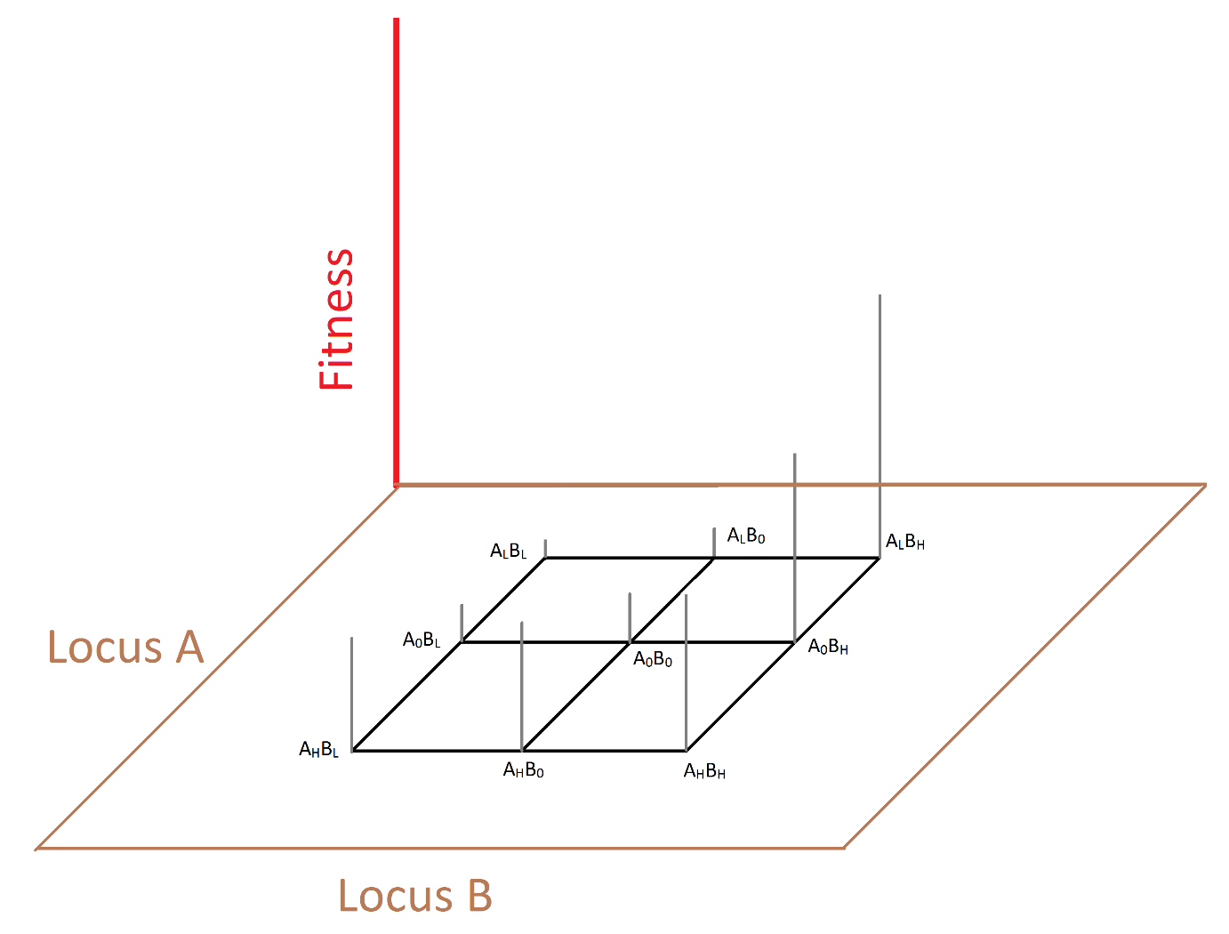

**Figure 1. Fitness landscape**

* The landscape presented above exhibits epistasis between locus A and locus B. Specifically, locus A exhibits *sign* epistasis on locus B backgrounds (Weinreich *et al.*, 2005).
* One can think of locus A as something that requires significant maintenance cost (e.g., energy in the form of ATP molecules) for its expression. On the other hand, locus B can be thought of as a structural protein that does not require much maintenance cost.
* We start the WF simulations with a clonal population of wild-type individuals. Every generation, the individuals reproduce clonally, and give rise to p offspring, where p is a function of its absolute fitness.
* Mutations occur with probabilities shown in Figure 2. Mutation probabilities would be so low that multiple mutations can’t occur at a given time. Overall, mutations that lower the expression of a given gene are much more common than mutations that enhance its expression. This is in agreement with the observations that deleterious mutations are more common than beneficial ones (Kassen and Bataillon, 2006; Eyre-Walker and Keightley, 2007).

Furthermore, mutations on locus A are much more common than mutations on locus B. One can imagine that locus A is much longer than locus B. Alternatively, whereas one can imagine locus B as a single locus, locus A can be thought of as a cluster (or composite or operon) of several genes. So, beneficial mutations on the maintenance-free locus (locus B) are extremely unlikely to come by (they are the so called extremely rare large-effect mutations (Sniegowski and Gerrish, 2010)).

* We would run the WF simulations at a wide range of population sizes, spanning several orders of magnitude.

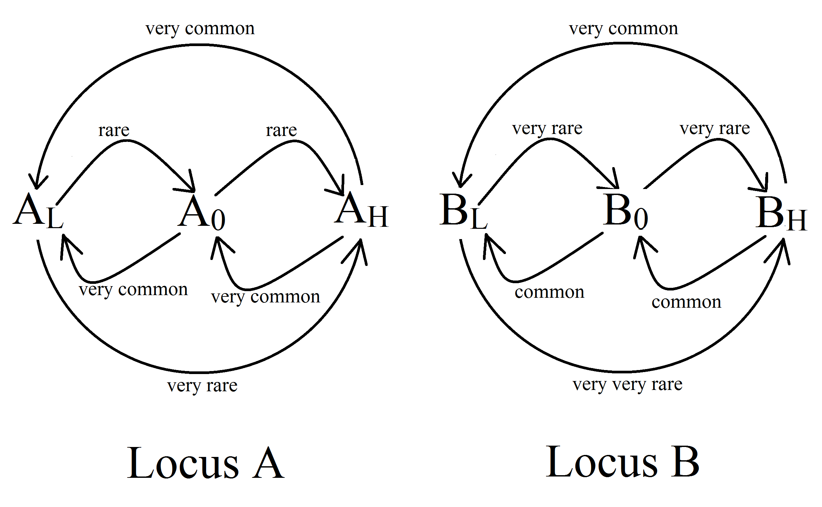

**Figure 2. Mutation probabilities**

**Expectations:** We expect all populations to adapt (increase their average fitness). Whereas large populations are expected to converge on the best-fit genotype (ALBH), small population won’t be able to access the highly rare beneficial mutations on locus B, and would therefore converge on AHB0.

In other words, while adaptation to the same environment would lead to loss of a biological trait in large populations, it would lead to an enhancement of this trait in small populations. This is because only the large populations would be able to access the rare highly rare benefits on locus B. Once the population stumbles upon this highly rare large-effect beneficial mutation (BH), it can now afford to lose the expression from locus A (which becomes superfluous and wasteful), thereby avoiding its high maintenance cost.

Unable to explore benefits on locus B, the smaller populations would only adapt via mutations on locus A, which would lead to an enhancement of the expression of trait A.

After meeting these goals, we wold remove epistasis and mutation-rate difference across locus A and B, one at a time, from the design of or model, and check if populations with drastically different sizes still converge on different genotypes as a result of adaptation. This analysis would lead to a minimalistic set of conditions that can explain the experimental observation that adaptation to the *same* environment can result in the decay or enhancement of a character based on differences in population size.

**References**

Cooper VS. (2014). The Origins of Specialization: Insights from Bacteria Held 25 Years in Captivity. *PLOS Biol* **12**: e1001790.

Eyre-Walker A, Keightley PD. (2007). The distribution of fitness effects of new mutations. *Nat Rev Genet* **8**: 610–618.

Fong DW, Kane TC, Culver DC. (1995). Vestigialization and loss of nonfunctional characters. *Annu Rev Ecol Syst* **26**: 249–268.

Jeffery WR. (2005). Adaptive Evolution of Eye Degeneration in the Mexican Blind Cavefish. *J Hered* **96**: 185–196.

Kassen R, Bataillon T. (2006). Distribution of fitness effects among beneficial mutations before selection in experimental populations of bacteria. *Nat Genet* **38**: 484–488.

Leiby N, Marx CJ. (2014). Metabolic Erosion Primarily Through Mutation Accumulation, and Not Tradeoffs, Drives Limited Evolution of Substrate Specificity in Escherichia coli. *PLoS Biol* **12**: e1001789.

Porter ML, Crandall KA. (2003). Lost along the way: the significance of evolution in reverse. *TRENDS Ecol Evol* **18**: 541.

Protas ME, Trontelj P, Patel NH. (2011). Genetic basis of eye and pigment loss in the cave crustacean, Asellus aquaticus. *Proc Natl Acad Sci* **108**: 5702–5707.

Sniegowski PD, Gerrish PJ. (2010). Beneficial mutations and the dynamics of adaptation in asexual populations. *Philos Trans R Soc B Biol Sci* **365**: 1255–1263.

Visser B, Lann CL, Blanken FJ den, Harvey JA, Alphen JJM van, Ellers J. (2010). Loss of lipid synthesis as an evolutionary consequence of a parasitic lifestyle. *Proc Natl Acad Sci* **107**: 8677–8682.

Weinreich DM, Watson RA, Chao L. (2005). Perspective: Sign Epistasis and Genetic Costraint on Evolutionary Trajectories. *Evolution* **59**: 1165–1174.